PHIL_1111OL

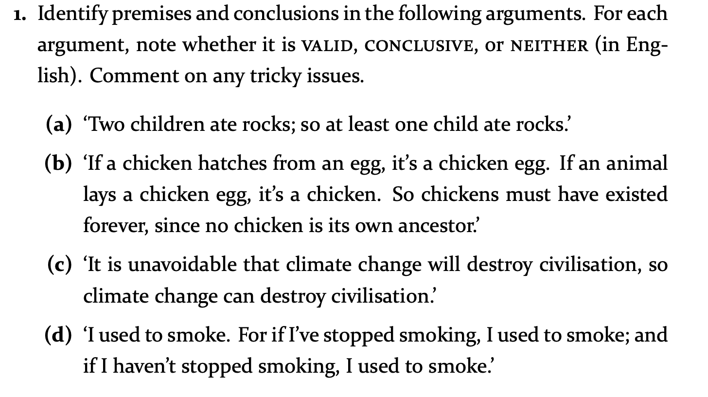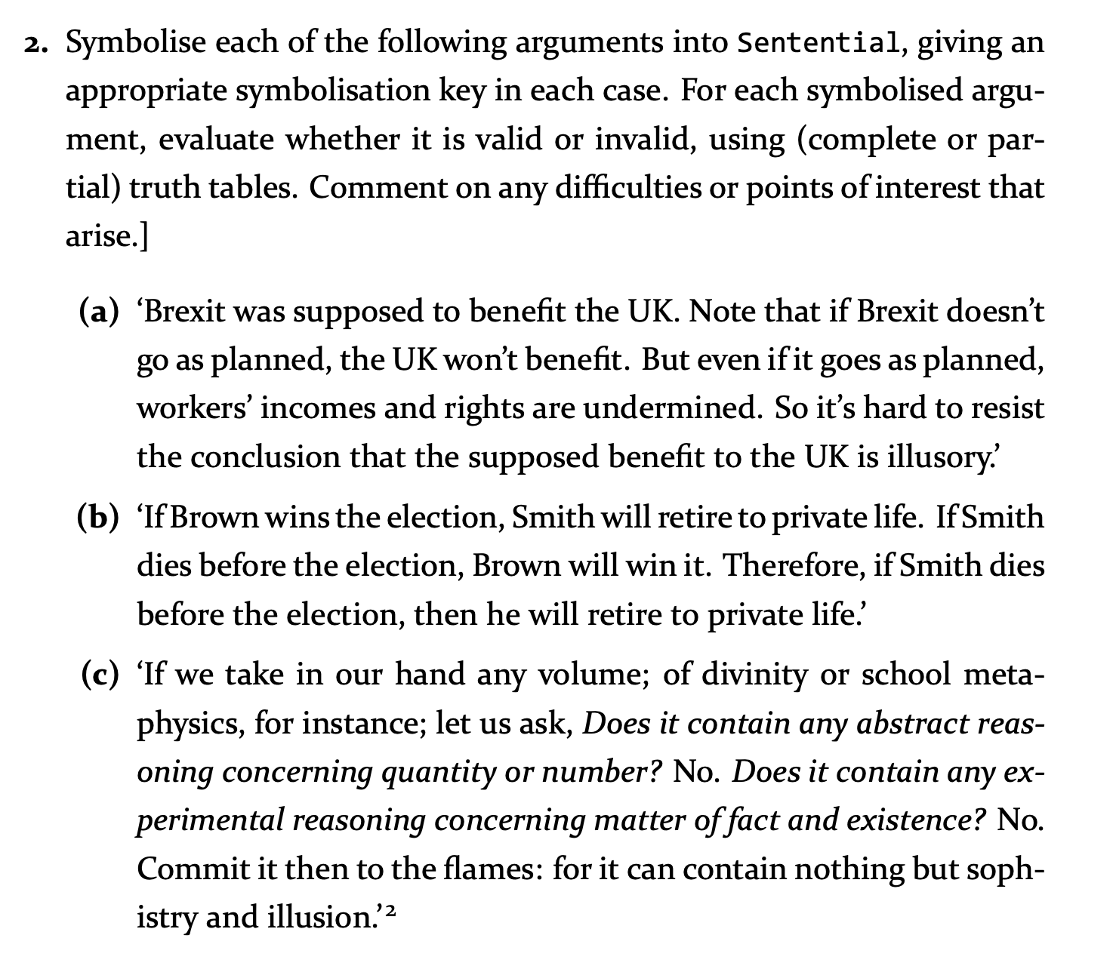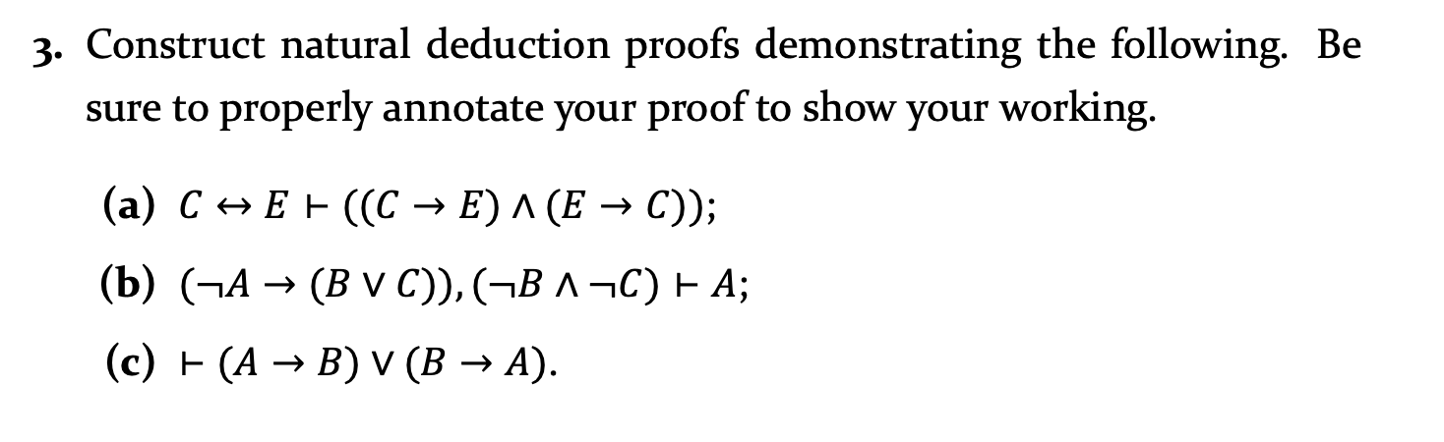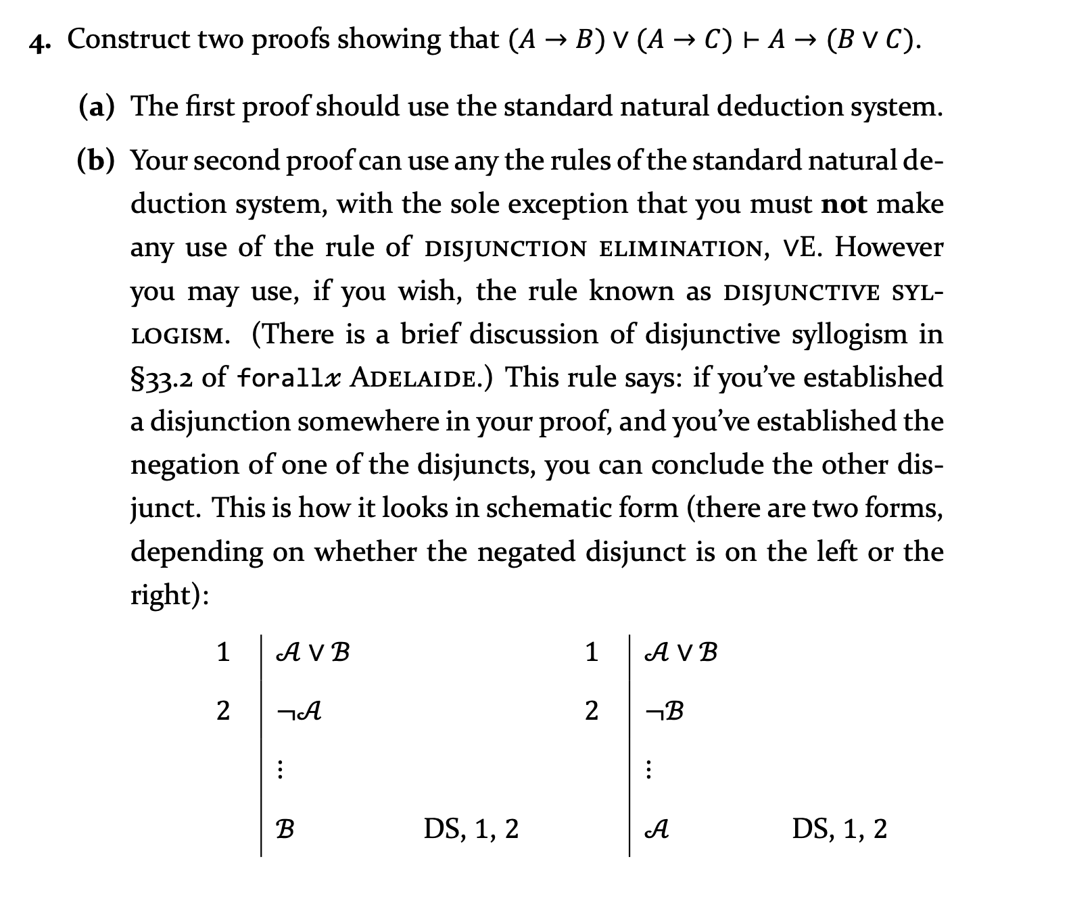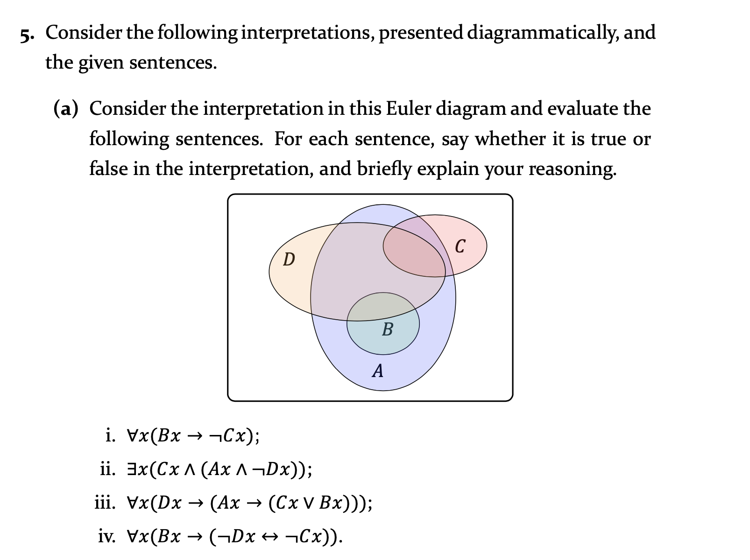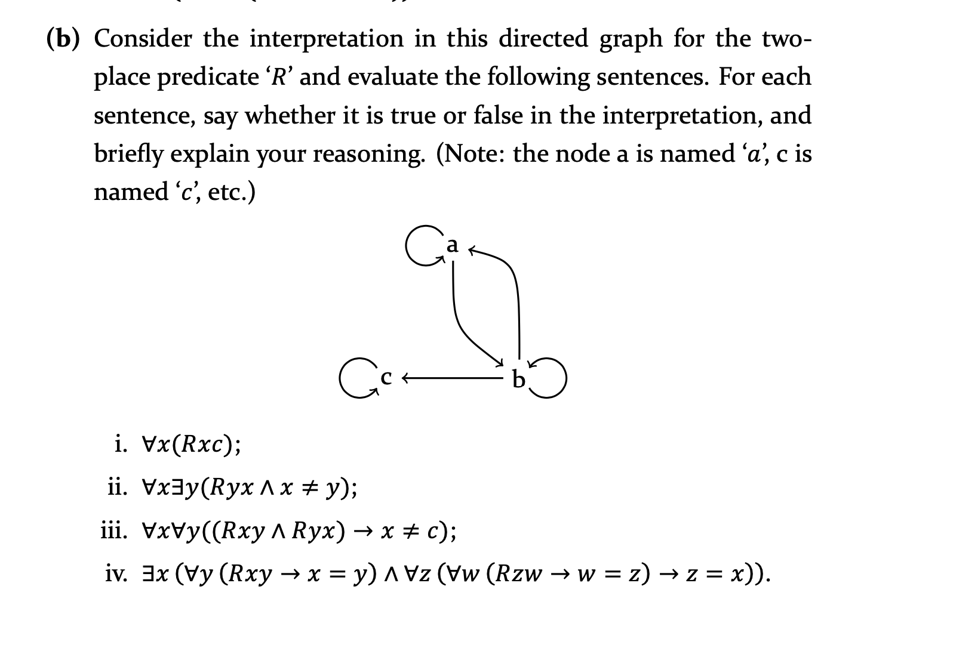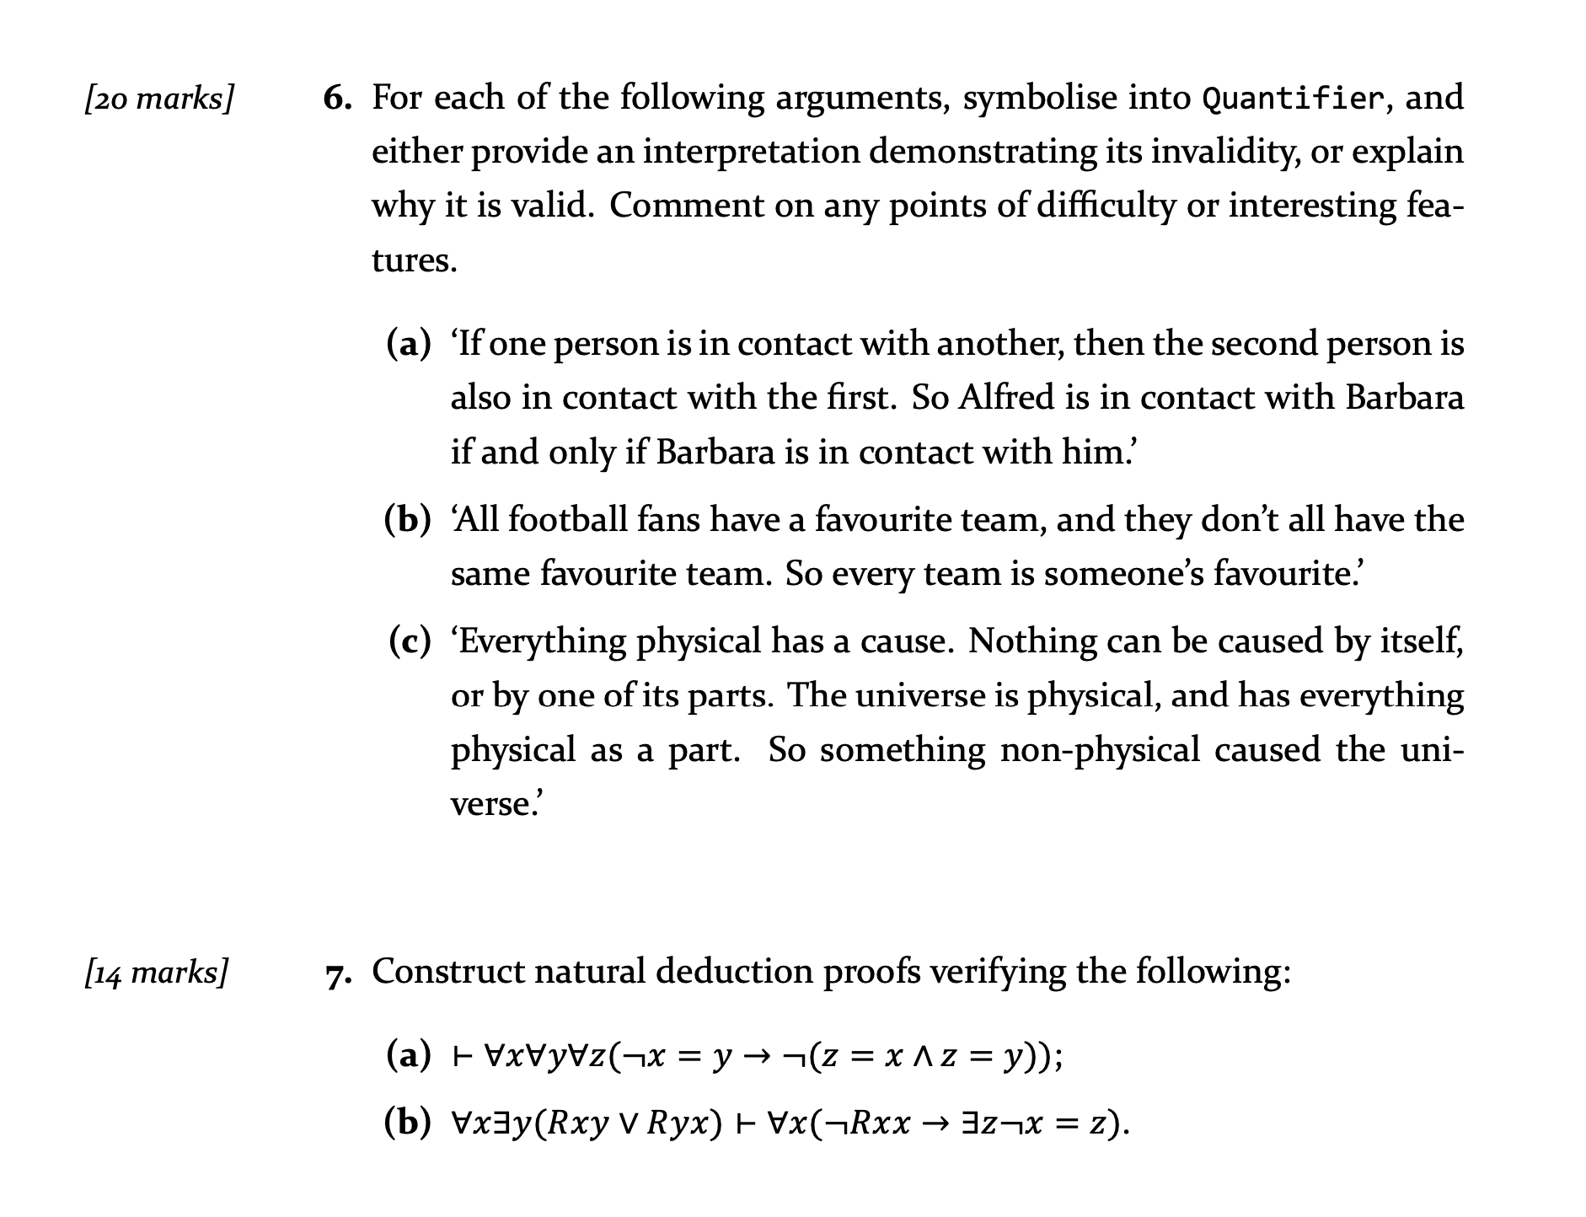

Q1

1a. Valid and conclusive, because the conclusion could be inferred from the premise. When the premise says, "two children ate rocks" which can be concluded "at least one child ate rocks." Also, if it is not at least one child ate rocks, the premise cannot be true, so this argument is valid and conclusive.

1b. Invalid and inconclusive, because the conclusion could not be inferred from the premise.

1c. valid and conclusive, because the conclusion could be inferred from the premise. When the premise says, "it is unavoidable that climate change will destroy civilisation". So, we can conclude that climate change can destroy civilisation". Also, if the climate change cannot destroy civilisation, "it is unavoidable that climate change will destroy civilisation" is false, so this argument is valid and conclusive.

1d. Neither, because this is not an argument.

Q2

2a. This argument is invalid. When both premises are true, the conclusion is false.

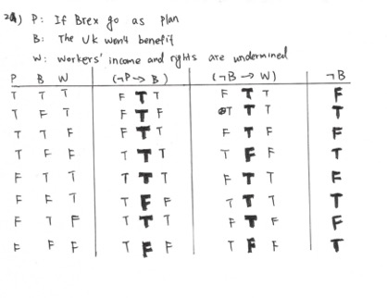

2b. This argument is valid, because at any conditions, when both premises are true, conclusion is true.

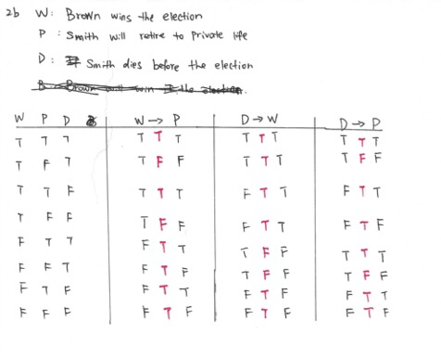

2c. This argument is valid, because there when the conclusion is false, premises are false.

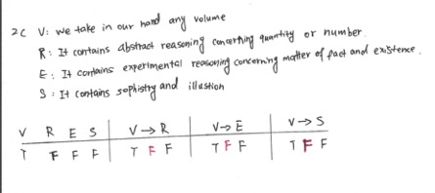

Q3

3a. 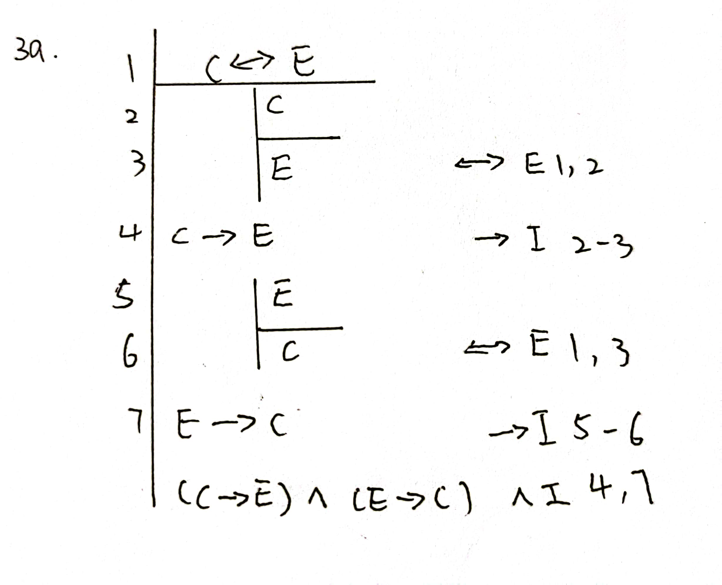

Q4

Q5

ai) True. In this diagram, Bs are a subset of A, and some Cs are A. But the associated regions of Bs and Cs do not overlap at all. Therefore, for all the x, if x in the B, then it does not in the C.

aii) True.

aiii) False

aiv) False

bi) True

bii) False. When x is not equal to y, y could approach all the x. However, because when y is a and x is c, this argument is invalid.

biii) True.

biv) True.

Q6

6a. It is valid.

Domain: people

F: __ is in contact with __.

S: __ is also in contact with __.

a: Alfred

b: Barbara

6b. valid

Domain: football fans

F: __ have a favourite team

S: __ don't have the same favourite team.

E: Every team is __ favourite

6c. valid

Domain: physical

E: __ has a cause

I: __ cannot caused by itself.

P: __ cannot caused by one of its parts

U: __ is __

A: __ has __ as a part

N: not __ caused the __

u: universal